Exploratory Pattern Two

* **a name for the pattern: OrganizerSearch**
* **a wireframe picture**

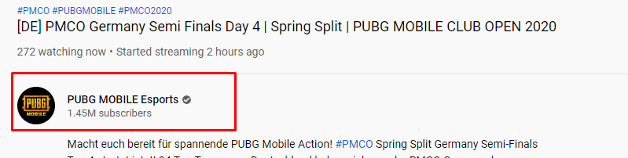



* **use when** (describes when the pattern should be applied)

1.Use to enable user find out other content from same author/organizer

2. Use to enable user find out the biography of event organizer

* **how** (describes how the pattern may be applied)

The idea is to provide a link to author profile, so user can search for more content created by same author (in the case of studEvents application, the events organized by particular person). Also, this pattern provides helpful link to organizer biography.

* **a discussion of** how you have applied this pattern in your own information seeking.

I have applied this pattern while following people on social media, such as Facebook, YouTube, twitter. While searching for information, I could just click on author’s profile and find out relevant information about my search request or about the author itself.